Assignment –1

1. Connect to Azure Cloud Shell 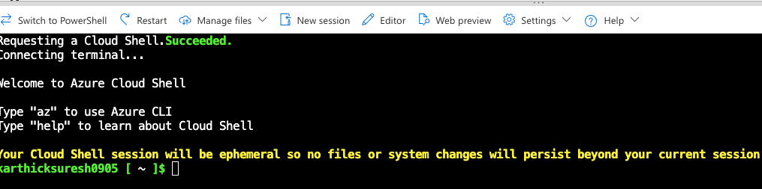

2. Create a resource group “new-rg” in South Central US region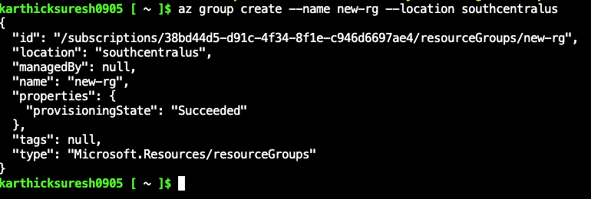

az group create --name new-rg --location southcentralus

Assignment –2

1. Connect Azure PowerShell to your Azure account 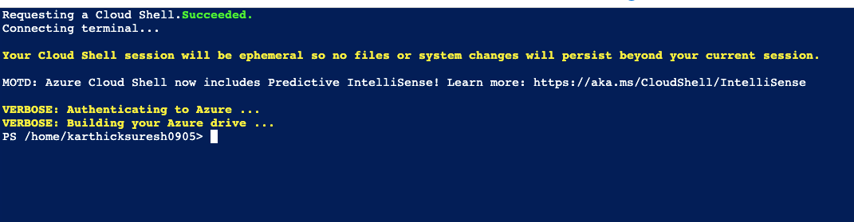

2. Create a new resource group in South Central US with the name “rg-powershell”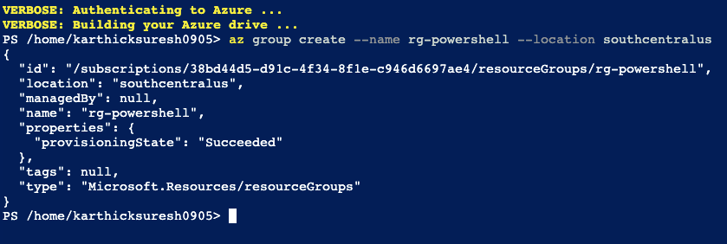az group create --name rg-powershell --location southcentralus

Assignment –3

1. Create three more resource groups in a specific region. For example: “West US” 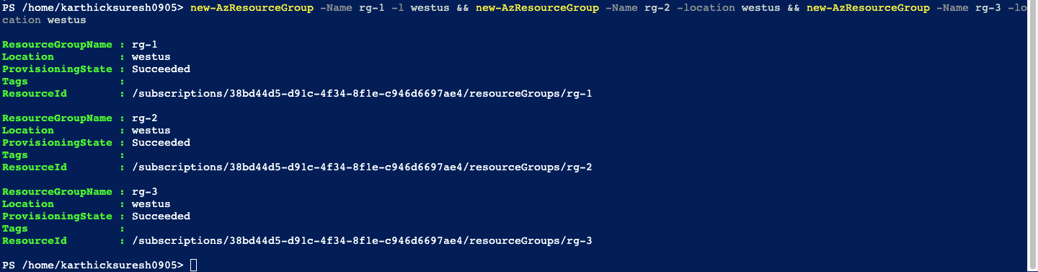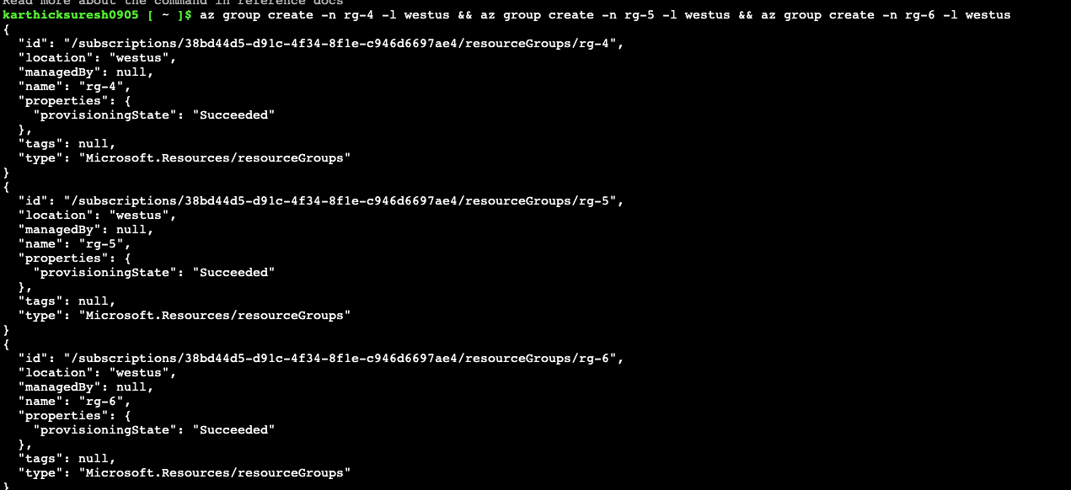

2. List all resource groups in West US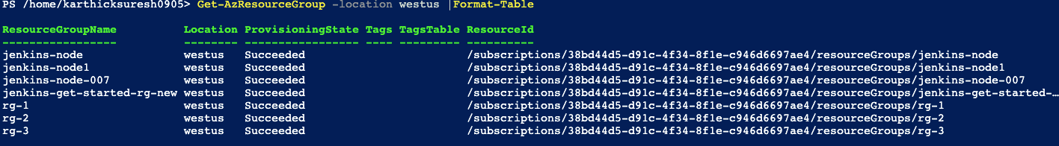

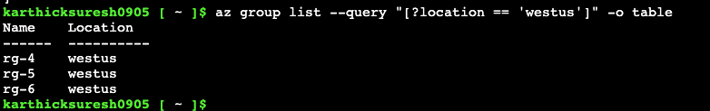

Assignment –4

1. Delete all the resource groups in West US region using one command

